# 

**Get-WindowsOptionalFeature 1**

**Installing Pre-Reqs for WSL 2**

Virtual Machine Platform 2

Windows Hypervisor Platform 2

Windows Subsystem for Linux 2

Install Linux Distros 2

**Install Windows Sandbox 2**

**Installing PowerShell 2**

**Installing WSL from MSStore 2**

**Installing Python from MSStore 2**

**Install Visual Studio Code 3**

**VSCode Default Extensions 3**

Prettier 3

VSCode-Icons 3

LUA 3

IntelliCode 3

C# 3

PowerShell 3

Python 3

YAML 3

WSL 3

Jupyter 4

Teams Toolkit 4

Power Platform Tools 4

Install in One Line 4

**Install RSAT using PowerShell 4**

Get Available RSAT tools 4

Install 4

**VSCode: Turn off Persistent Session 5**

**Ubuntu 5**

VSCode install 5

PowerShell Install 5

# 

# Get-WindowsOptionalFeature

Get-WindowsOptionalFeature -Online

# Installing Pre-Reqs for WSL

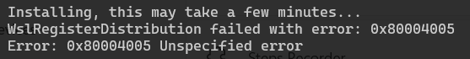

Fix: wsl --update

## Virtual Machine Platform

Enable-windowsoptionalfeature -online -featurename VirtualMachinePlatform

## Windows Hypervisor Platform

Enable-WindowsOptionalFeature -online -featurename HypervisorPlatform

## Microsoft Hyper-V

Enable-WindowsOptionalFeature -online -featurename Microsoft-Hyper-V-All

## Windows Subsystem for Linux

enable-windowsoptionalfeature -online -featurename Microsoft-Windows-Subsystem-Linux

## Install Linux Distros

Wsl --install -d kali-linux

# Install Windows Sandbox

Enable-WindowsOptionalFeature -FeatureName "Containers-DisposableClientVM" -Online -NoRestart

# Installing PowerShell

winget install “Microsoft.PowerShell”

# Installing WSL from MSStore

winget install “Windows Susbsytem for Linux” -s msstore

# Installing Python from MSStore

winget install “Python 3.12” -s msstore

# Install Visual Studio Code

Winget install “Microsoft.VisualStudioCode”

# VSCode Default Extensions

## Prettier

code --install-extension esbenp.prettier-vscode

## VSCode-Icons

code --install-extension vscode-icons-team.vscode-icons

## LUA

code --install-extension sumneko.lua

## IntelliCode

code --install-extension VisualStudioExptTeam.vscodeintellicode

## C#

code --install-extension ms-dotnettools.csharp

## PowerShell

code --install-extension “ms-vscode.powershell”

## Python

code --install-extension “ms-python.python”

## YAML

code --install-extension “redhat.vscode-yaml”

## WSL

code --install-extension “ms-vscode-remote.remote-wsl”

## Jupyter

code --install-extension “Ms-toolsai.jupyter”

## Teams Toolkit

code --install-extension “TeamsDevApp.ms-teams-vscode-extension”

## Power Platform Tools

code --install-extension “microsoft-IsvExpTools.powerplatform-vscode”

## Install in One Line

code --install-extension esbenp.prettier-vscode --install-extension vscode-icons-team.vscode-icons --install-extension sumneko.lua --install-extension VisualStudioExptTeam.vscodeintellicode --install-extension ms-dotnettools.csharp --install-extension ms-toolsai.jupyter --install-extension ms-vscode.powershell --install-extension ms-python.python --install-extension ms-vscode-remote.remote-wsl --install-extension redhat.vscode-yaml --install google.geminicodeassist

# Install RSAT using PowerShell

## Get Available RSAT tools

Get-WindowsCapability -Name “RSAT*” -Online | FT Name,DisplanyName,State -Quto -Wrap

## Install

$rsat_tools = @(

"Rsat.ActiveDirectory.DS-LDS.Tools~~~~0.0.1.0",

”Rsat.DHCP.Tools~~~~0.0.1.0”,

”Rsat.Dns.Tools~~~~0.0.1.0”,

”Rsat.GroupPolicy.Management.Tools~~~~0.0.1.0”,

”Rsat.ServerManager.Tools~~~~0.0.1.0”

)

foreach ($rsat_tool in $rsat_tools) {

Add-WindowsCapability -Online -Name $rsat_tool

}

# VSCode: Turn off Persistent Session

Terminal > Integrated: Persistent Seession Review Process -- never

Terminal > Integrated: Enable Persistent Sessions -- off

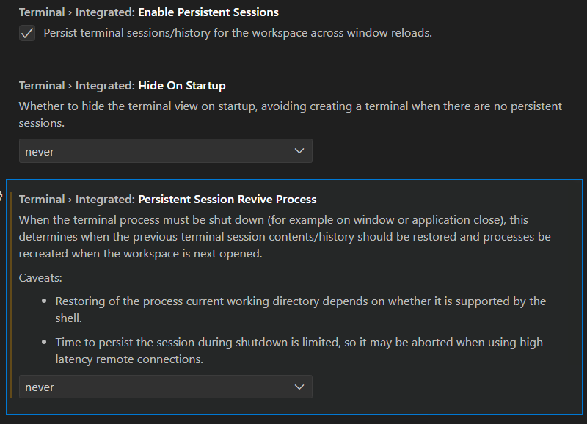

# Ubuntu

## VSCode install

sudo apt install code

## PowerShell Install

###################################

# Prerequisites

# Update the list of packages

sudo apt-get update

# Install pre-requisite packages.

sudo apt-get install -y wget apt-transport-https software-properties-common

# Get the version of Ubuntu

source /etc/os-release

# Download the Microsoft repository keys

wget -q https://packages.microsoft.com/config/ubuntu/$VERSION_ID/packages-microsoft-prod.deb

# Register the Microsoft repository keys

sudo dpkg -i packages-microsoft-prod.deb

# Delete the the Microsoft repository keys file

rm packages-microsoft-prod.deb

# Update the list of packages after we added packages.microsoft.com

sudo apt-get update

###################################

# Install PowerShell

sudo apt-get install -y powershell

# Start PowerShell

pwsh